

**KUMASI TECHNICAL UNIVERSITY**

INSTITUTE OF DISTANCE AND CONTINUING EDUCATION

COMPUTER SCIENCE DEPARTMENT

PROJECT NAME:

**E-COMMERCE WEBSITE FOR ORDERING**

**FRUIT JUICE**

A PROJECT SUBMITTED TO THE COMPUTER SCIENCE DEPARTMENT

IN PARTIAL FULFILLMENT OF THE REQUIREMENT FOR THE AWARD OF DIPLOMA IN INFORMATION TECHNOLOGY

PRESENTED BY:

**OPPONG ANSAH JOSEPH - 052020760165**

**KWAKYE SHADRACK – 052020760129**

**ASAMOAH PRINCE – 052020760057**

JULY 2020

# **TABLE OF CONTENTS**

TABLE OF CONTENTS ii

DECLARATION & ACKNOWLEDGEMENT iii

CHAPTER ONE 1

INTRODUCTION 1

CHAPTER TWO 2

DESCRIPTION OF INTERFACES 2

CHAPTER THREE 3

ANALYSIS OF THE IMPLEMENTED SYSTEM 3

CHAPTER FOUR 4

CONCLUSION 4

**DECLARATION**

We hereby declare that this project works E-Commerce Store for Fruit Juices. Has been prepared by us during the year 2022 under the guidance of the Department of Computer Science, Kumasi Technical University in the partial fulfillment of the Diploma in Information Technology prescribed by the university.

We also declare that this project is the outcome of our effort and has not been submitted to any other university for the award of any degree.

**ACKNOWLEDGMENT**

First and foremost, we would like to express our sincere thanks to the almighty God for the gift of life, wisdom understanding he has given to the team, a reason for our existence, and each various families for the love and support they had been provided throughout the course. We cannot forget the friends in the faculty of Computer Science for the academic interactions and Ideas.

Finally, we extend our acknowledgment to all the other staff and our senior colleagues of the Computer Science Department, the H.O.D, and our patron Mr. S.K Opoku. May the good lord bless them and keep them safe. We love you all.

**DEDICATION**

We wish to dedicate this entire project report to each beloved team member for the tireless support they accorded throughout the project. We also extend our sincere gratitude to the friends for their moral support. Above all, to the Almighty God for good health and sound mind throughout our studies.

# **CHAPTER ONE**

# **INTRODUCTION**

An E-commerce website requires an appropriate strategy for successful design and implementation. Everything is required to plan from scratch to the end of the website. The e-commerce website will feature an online shopping facility for various drinking products under a single web space. The proposed web application will allow business personnel to make their total business using it and increase their reachability thousands of times more than today they have, over the internet. It will allow multiple shopping vendors to sell their products online. The product management in the system will be done in the form of categories.

**WHY DEVELOPING SYSTEM (BENEFIT AND MOTIVATION)**

* Ecommerce sites empower businesses to reach new markets and gain resilience by selling if their brick-and-mortar stores have to close.
* If you're just starting a business, an eCommerce site can give you a worldwide market and brand recognition before you even open a physical store.
* Customers can take enjoy online shopping 24 hours per day.
* Consumers can purchase any goods and services anytime at everywhere.
* Online shopping is user-friendly compared to in-store shopping because consumers can just complete their requirements just with a click of a mouse without leaving their homes.

# **CHAPTER TWO**

# **DESCRIPTION OF INTERFACES**

The UI/UX is critical to eCommerce because it ensures that customers can easily navigate, find what they need, buy it, and move on. And we make it easy for people to buy from our website, they'll buy more frequently. That's why we have to make sure to offer the best UX possible.

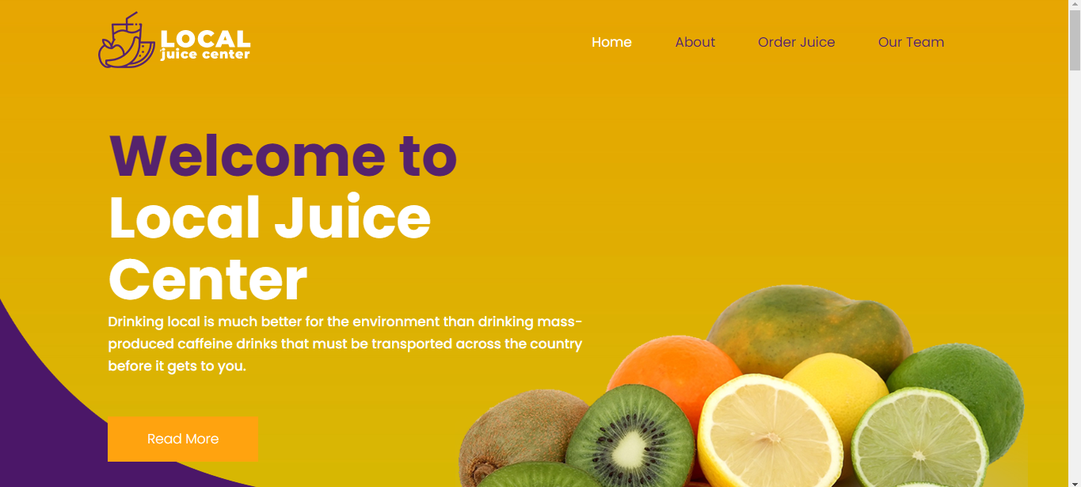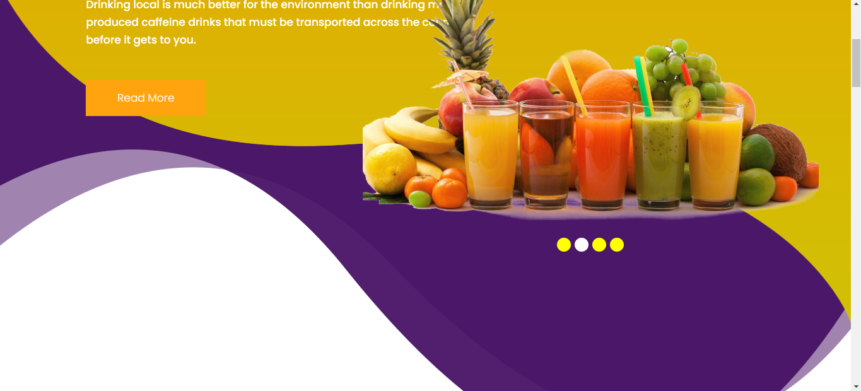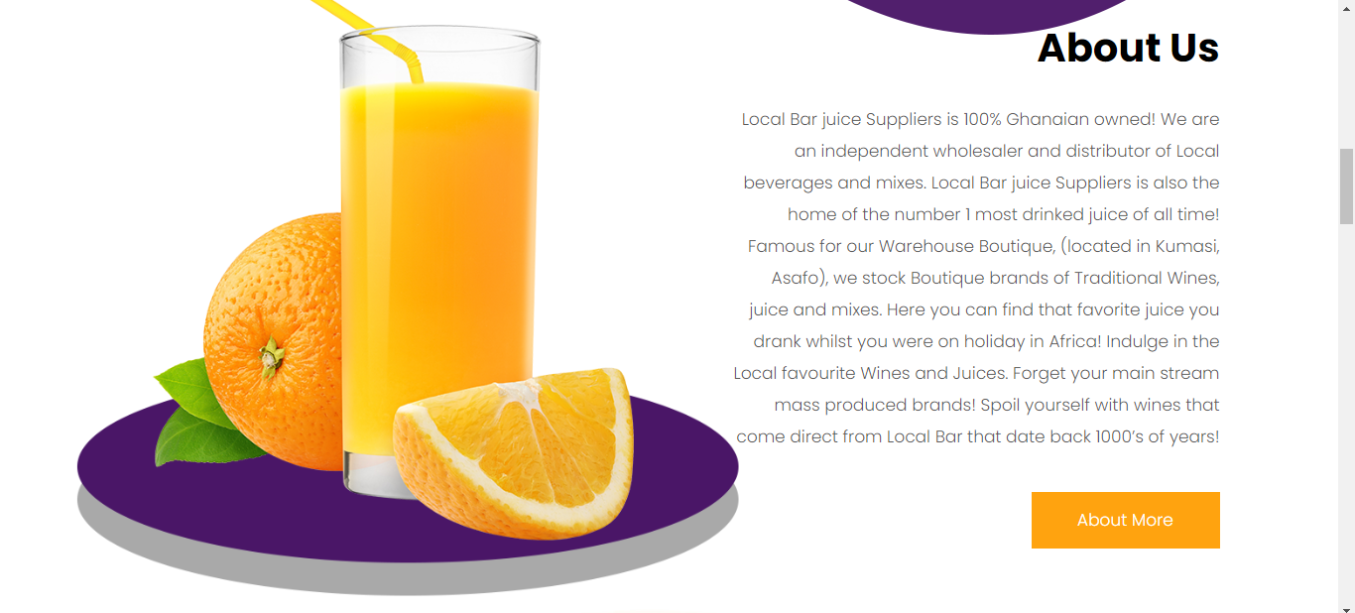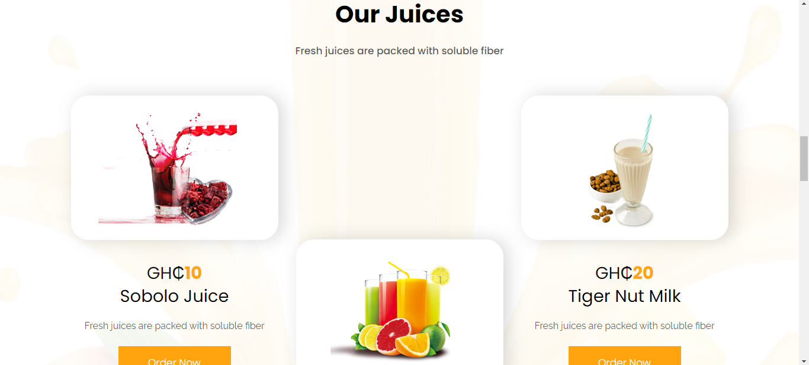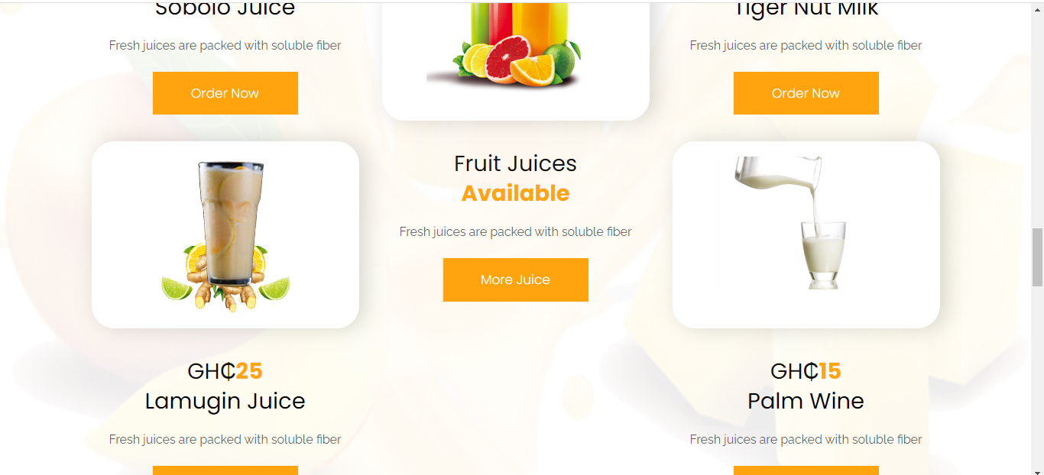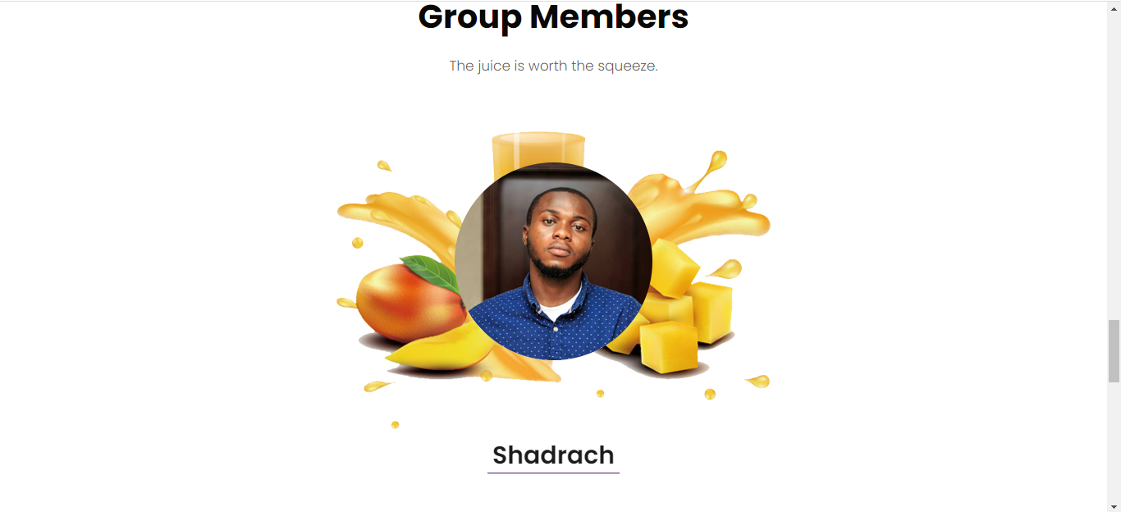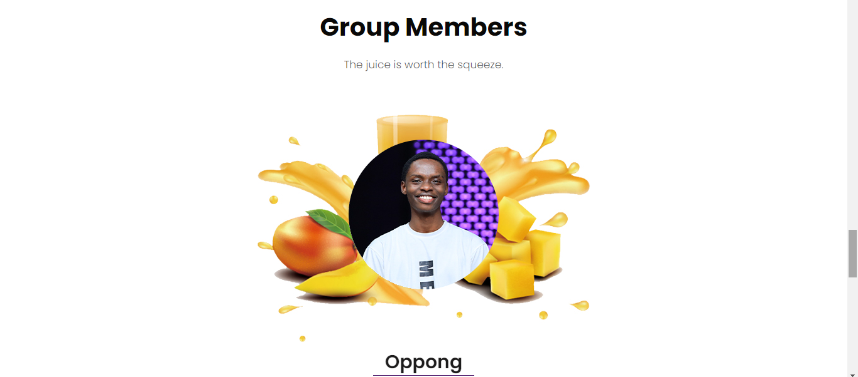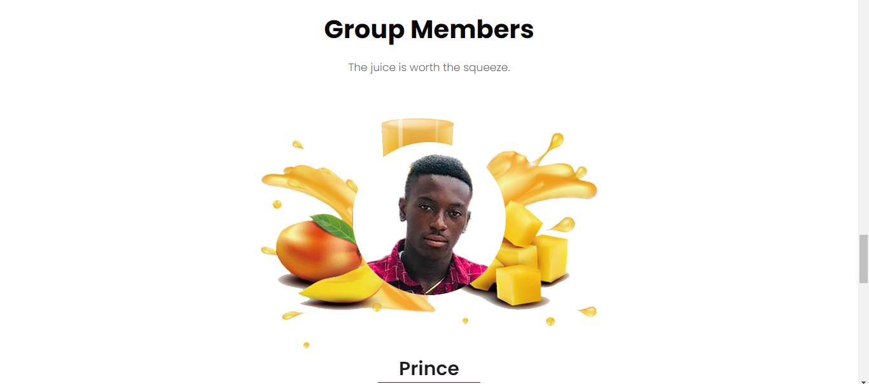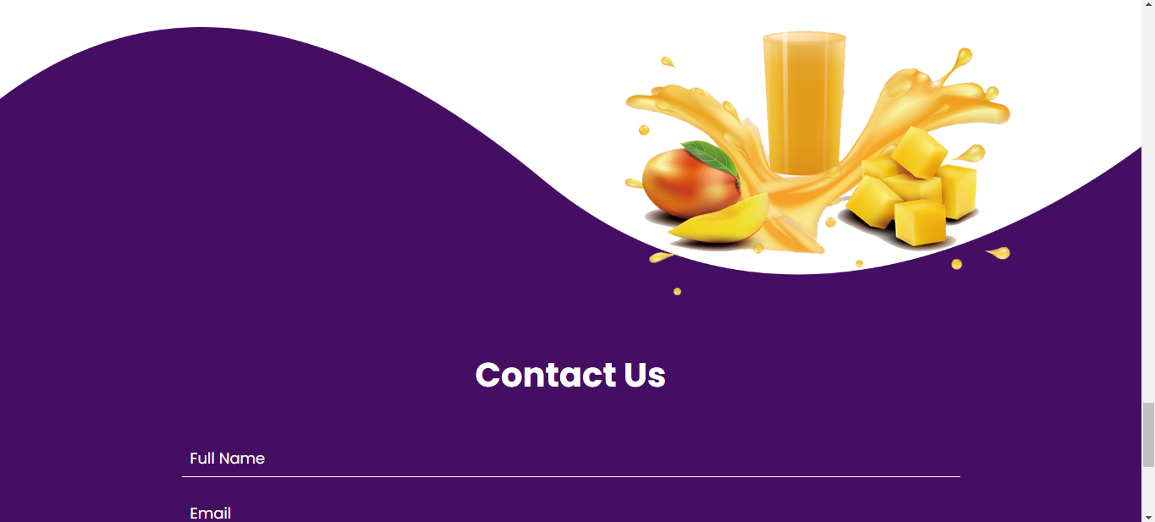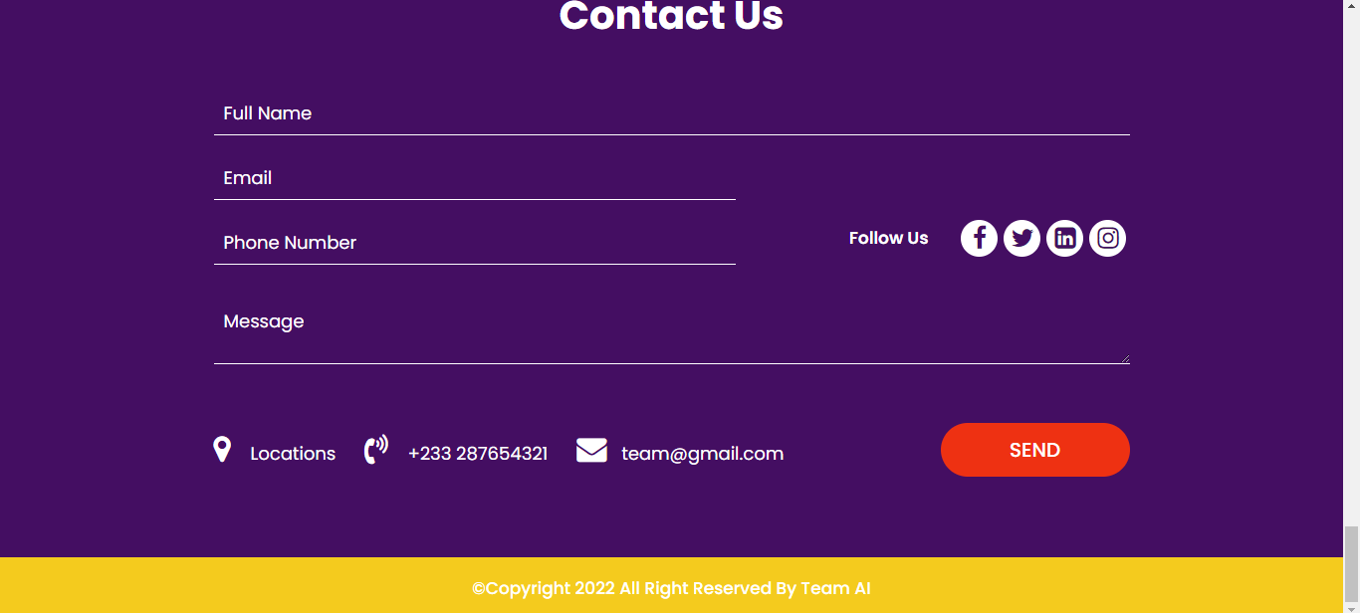

# 

# **CHAPTER THREE**

# **ANALYSIS OF THE IMPLEMENTED SYSTEM**

**Aims And Objectives**

The main objective of the study is to develop an online drinking system. The system aims to achieve the following objectives:

* To design an online Local drinking system.
* To provides a solution to reduce and optimize the expenses of foreign drinks.
* To create an avenue where people can feel free and enjoy purchasing local drinks.

**Online shopping has some advantages like below:**

* Save the Time of the consumers.
* They can purchase any time anywhere.
* They can compare the price with the other retailers very easily.
* Compare the advertising price and actual price.
* They can easily track their product.
* They can purchase the product from foreign marketers.

**CHAPTER FOUR**

# **CONCLUSION**

**Limitations of the website**

A major limitation of this juice website is its dis dependency on the availability of the internet and the devices needed to browse the internet through, such as laptops and mobile devices.

The following are some of the limitations or disadvantages of e-commerce**:**

* Security; The biggest drawback of e-commerce is the issue of security.
* Lack of privacy
* Tax issue
* Fear
* High Labor cost
* Legal issues.

**Recommendations**

There are many benefits to recommending customers specific products, some of which have listed below:

* Better user experience
* Easier inventory management
* Higher customer engagement
* Increased revenue